NETWORKING & SYSTEM ADMINISTRATION LAB

**Name: Nikhil Jais**

**Roll No: 25**

**Batch: B**

**Date: 24-03-22**

Experiment No.: 7

Aim

Familiarization of basic Linux commands.

**PROCEDURE**

1. **sudo useradd vishnu :** command in Linux that is used to add user accounts to yoursystem.

Syntax : sudo useradd <username> Output:

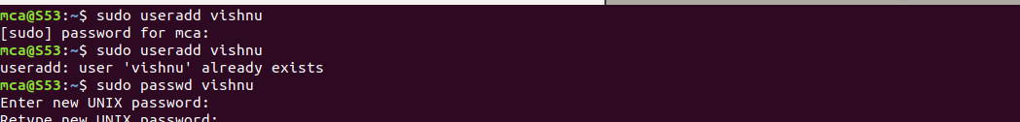

1. **sudo passwd vysh :** passwd command in Linux is used to change the user account passwords.

Syntax : sudo passwd username Output:



1. **sudo groupadd –g 5000 MSC :** The groupadd command creates a new group account.

Syntax : sudo groupadd –g <id><group name>

Output:



1. **sudo usermod -G MSC EEE :** To change the group of a user

Syntax : sudo usermod -G <group name><user name> Output:



1. **id vysh :** id command in Linux is used to find out user and group names and numeric ID's (UID or group ID) of the current user or any other user in the server.

Syntax : id<username> Output :



1. **compgen -g** : list all the groups.

Syntax : compgen -g Output:

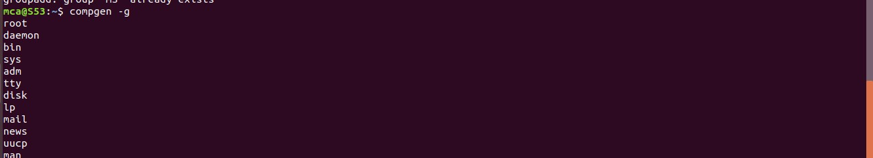

1. **sudo userdel vishnu :** removes user account.

Syntax : sudo userdel <username> Output:



1. **sudo groupdel MS:** delete an existing group.

Syntax : sudo groupdel<group name> Output:



1. **compgen -g MSC:** to list the mentioned group.

Syntax : compgen -g <group name> Output:



10.**chmod +rwx v.txt :** to add permissions.

Syntax : chmod +rwx filename Output:



1. **chmod -wx v.txt :** to take out write and executable permissions.

Syntax : chmod -wx filename Output:



1. **chmod -rwx v.txt :** to remove permissions.

Syntax : chmod -rwx filename Output:



1. **sudo chown vjk v.txt :** chown command is used to change a file's ownership, directory, or symbolic link for a user or group.

Syntax : sudo chown user name filename.txt Output:

